ZHOU Kevin
Student ID : A0197122H
NUS - IE5101 - Applied Forecasting Methods
Professor : Chen Nan
Project 2 : Forecasting Highway Car Volumes


Table of Contents
2.1 Regression on Time 2
2.1.1 Regression on time 2
2.1.2 Diagnostic check 3
2.1.3 Model interpretation 4
2.2 Exponential Smoothing 4
2.2.1 Naive application of Exponential smoothing 4
2.2.2 Verification of model choice, upsides and downsides 5
2.2.3 Holt-Winters exponential smoothing 6
2.3 Free form forecasting 6
2.3.1 Data cleaning 7
2.3.2 Linear regression 7
2.3.3 ARIMA 7
1-deseasonalize a time series needed if that series is stationary ? Is a seasonal series stationary ? 9

2.1 Regression on Time

2.1.1 Regression on time
In this first part our regression will only consider the variables Time and TrafficVolume for prediction.
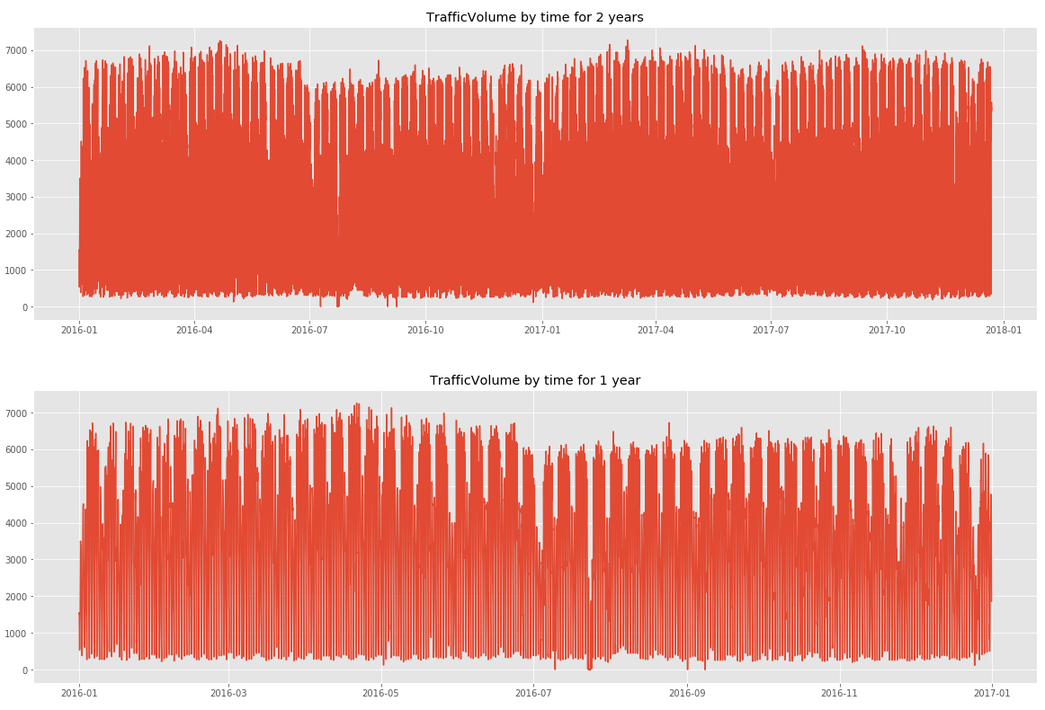
By plotting the Traffic volume, we notice some seasonality linked to the hour (peak around 7 am to 5 pm), to the day of the week (low traffic during the weekend) and and also to the month (plateau around April and minimum around July)
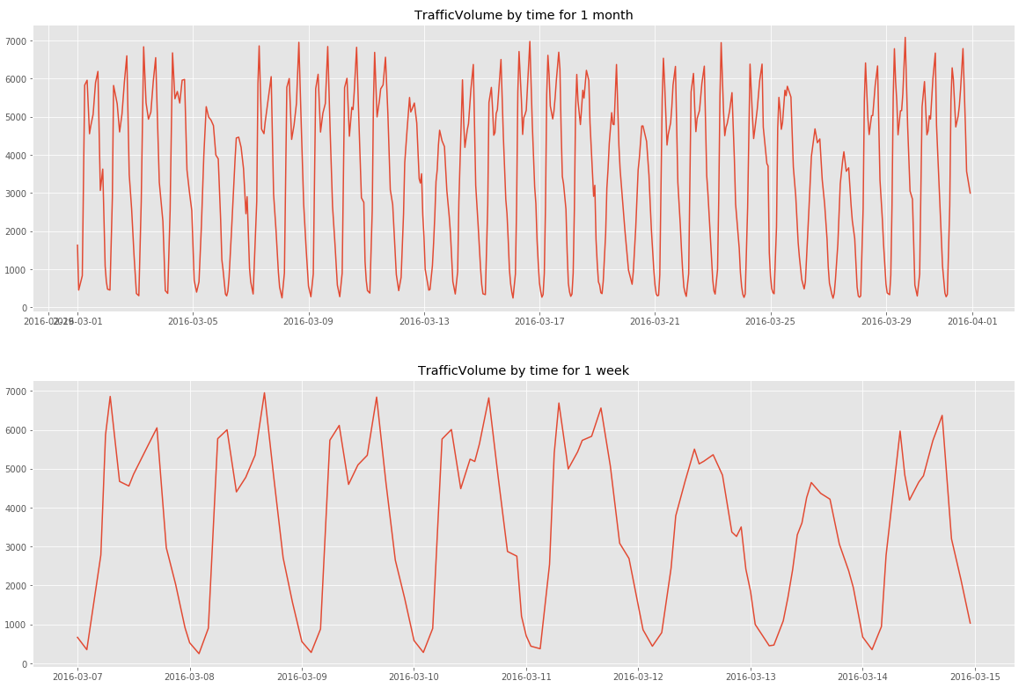
Hence to compute the linear regression, we will introduce dummy variables for the hour of the day, the day of the week and the month of the year and add the year to account for possible trend in time
To ease the interpretation, we have standardized the year variable: Year= Year -2012

We have opted for time series regression with no trend and constant additive seasonal variation ie y_{t}= TR_{t} + SN_{t} + ε_{t} assuming :
- TR_{t}= β₀ with β₀ constant
- SN_{t}= β_{S1}*x_{S1,t}+ β_{S2}*x_{S2,t}+ … +β_{SN}*x_{SN,t}
with x_{Si} the dummy variables related to the seasonal variation
More precisely x_{Si,t}= 1 if time period t is Si (season i) , 0 otherwise
This has yielded satisfactory results (below). All variables are taken are extremely relevant (p-values close to 0) except C(monthofyear)[T.12].

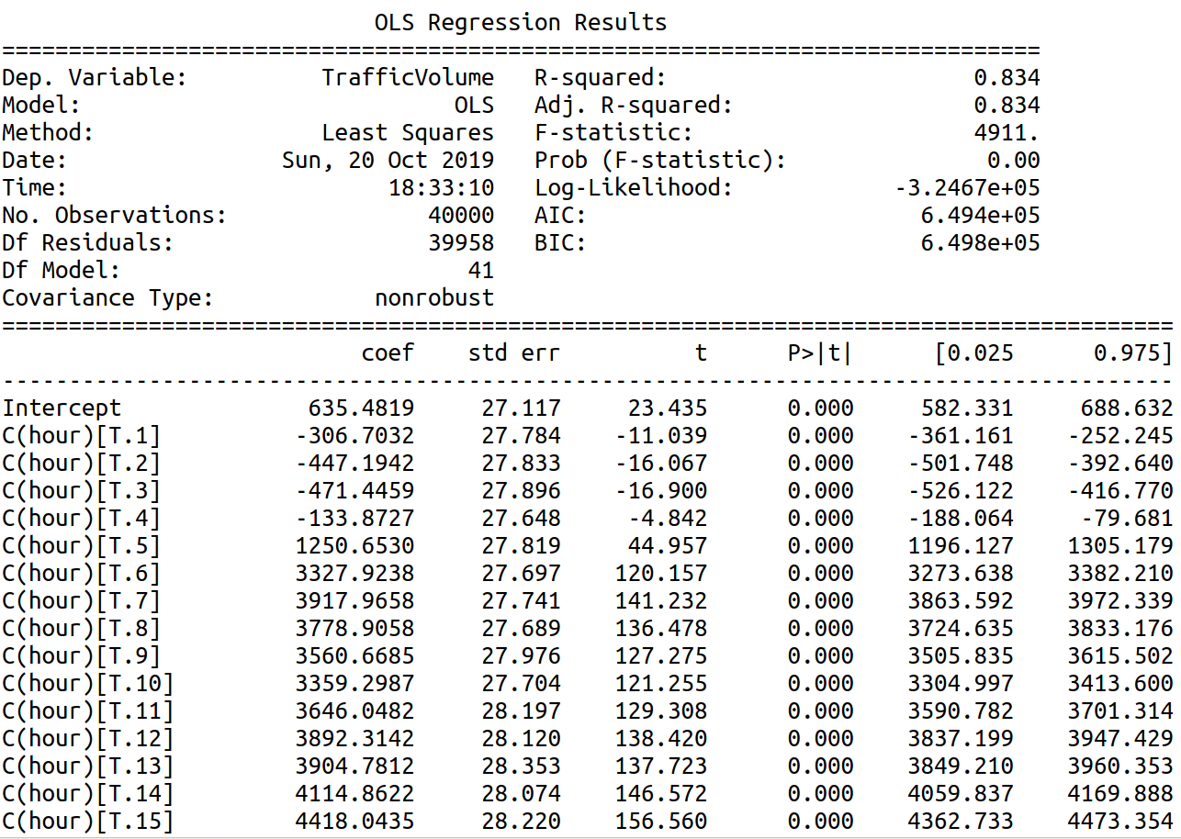
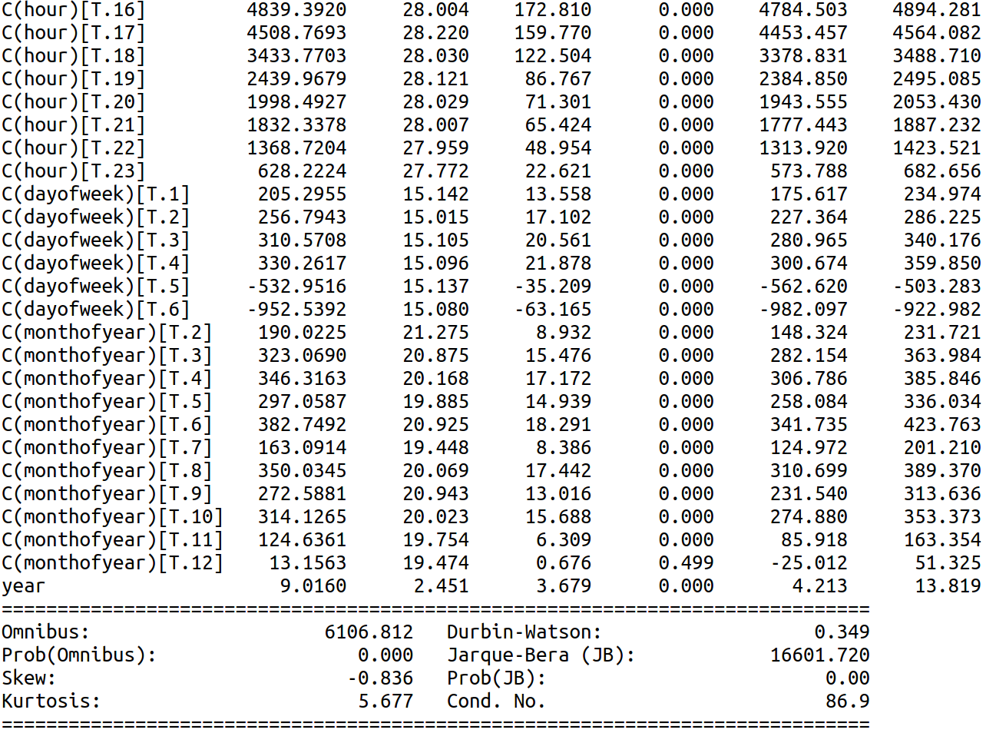
A full model regression with the list of possible features below have resulted in a slightly better R²-adjusted and smaller AIC. A stepwise forward selection regression to automatically select the best variables yielded similar results : better R²-adjusted and smaller AIC.
(‘hour', 'C(hour)', 'dayofweek', 'C(dayofweek)', 'dayofmonth', 'C(dayofmonth)', 'dayofyear', 'C(dayofyear)','C(weekofyear)', 'weekofyear', 'C(monthofyear)', 'monthofyear','year')
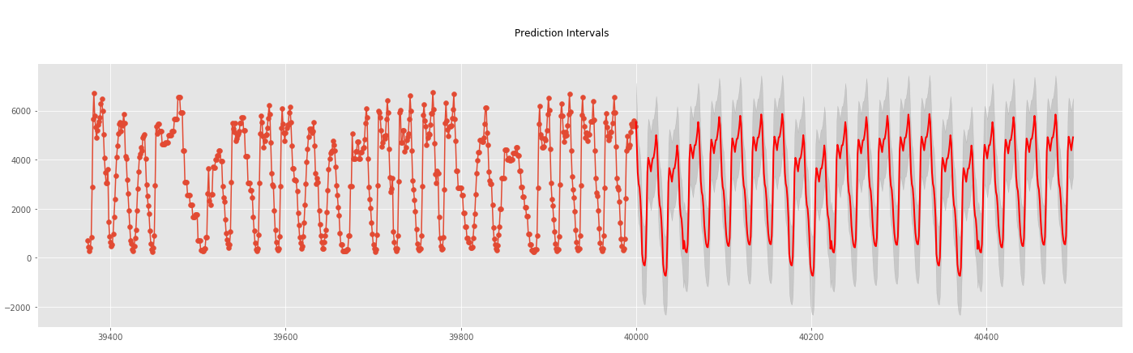
Both yielded slightly better results (1.1 point higher in R²-adjusted and 2000 lower in AIC) but have much complex models. For ease of interpretation, we will opt for the first regression model based on the AIC criteria.
Predicting future dates gives the right seasonal trend with however some values below 0.

2.1.2 Diagnostic check
-Residuals plot shows a non-normally distributed set of residuals especially for the lower quantiles with non-constant growing variance of the residuals when compared to the fitted values. Assumption of homoscedasticity for the linear regression has been broken.
-Moreover, when fitted values are negatives, residuals are always positive. This is because the prediction intervals should always have an inferior bound of 0.
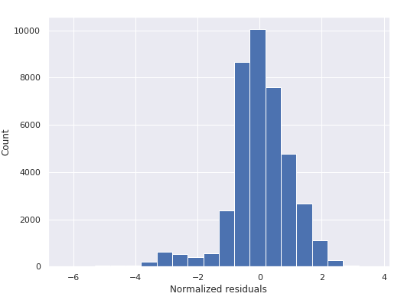
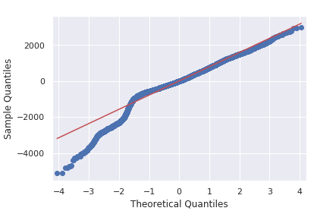
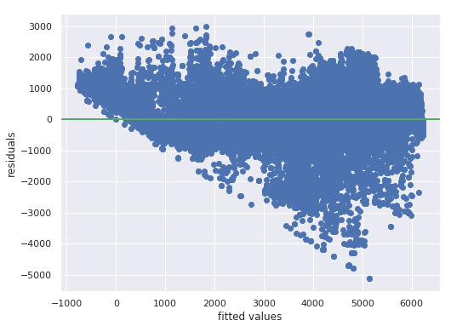

2.1.3 Model interpretation
The year is present in our model as a normal feature of linear regression. We have included 3 levels of seasonality : hour, day of the week, month of the year.
The base value is 635.48 at base hour, base day of week and base month.
- The base hour is hour 00:00. We observe that hours between 1:00 and 4:00 have negative coefficients in front of the related dummy variables and hours between 5:00 to 23:00 have positive coefficients with a culminating point at 16:00.
C(hour)[T.16] =4839.3920 can be interpreted as : the model predicts that under the exact same context and variables (ie same features) and only changing the hour from 00:00 to 16:00 would increase the Traffic Volume by 4839 units.
- The base day is dayofweek=0, ie monday. High traffic seems to be in working days with a maximum on dayofweek=4, ie Friday. We note that variation across days are less important than variation across hours
- The base month is month=1 ie January. All coefficients are positive meaning that January can be seen as the month with the lowest traffic. There are 2 peak periods : from March to June and from August to October.

2.2 Exponential Smoothing
We will then apply exponential smoothing to make forecasting. Please explore
and verify your choice of model, and elaborate potential pros and cons of the model.

2.2.1 Naive application of Exponential smoothing
We will apply a simple exponential smoothing based on the assumption that the observations follow a constant trend modal:
y_{t} = β₀ +ε_{t} with β₀ the constant term and ε_{t} the random residual term
We will calculate the optimal alpha given the SSE = Σ[Y_{i} - L_{i-1}]²
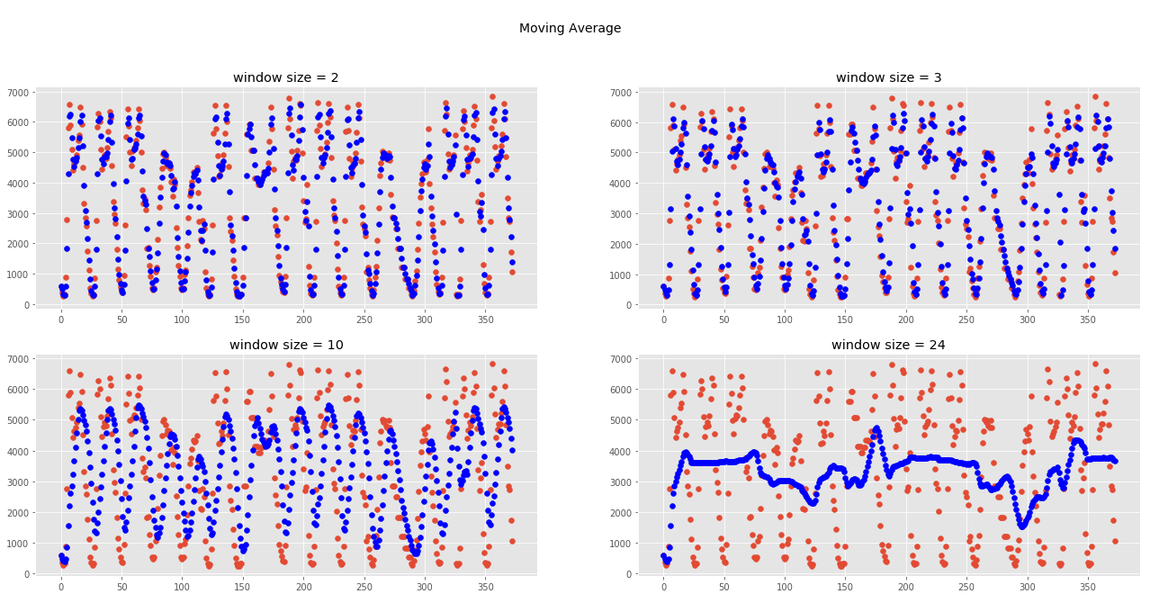
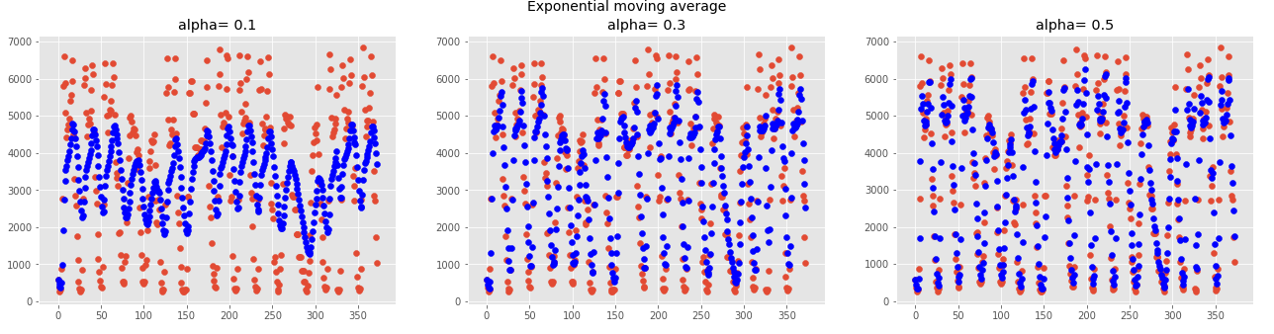
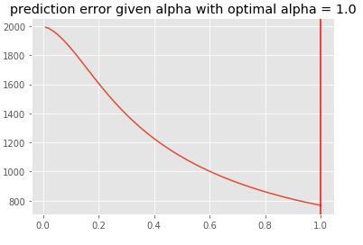
This resulted in an optimal alpha of 1.0 ie the optimal prediction of Y_{n} is L_{n-1}= αY_{n-1}+(1-α) L_{n-2} =Y_{n-1}. The best estimation is the previous value. We may need to review our assumptions when using the exponential smoothing.

2.2.2 Verification of model choice, upsides and downsides
The exponential smoothing is based on constant parameters (ie TR_{t}, SN_{t,}) and constant variance over time.
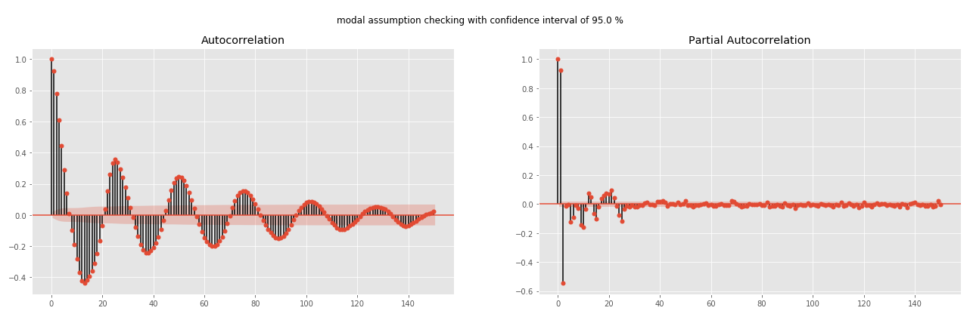
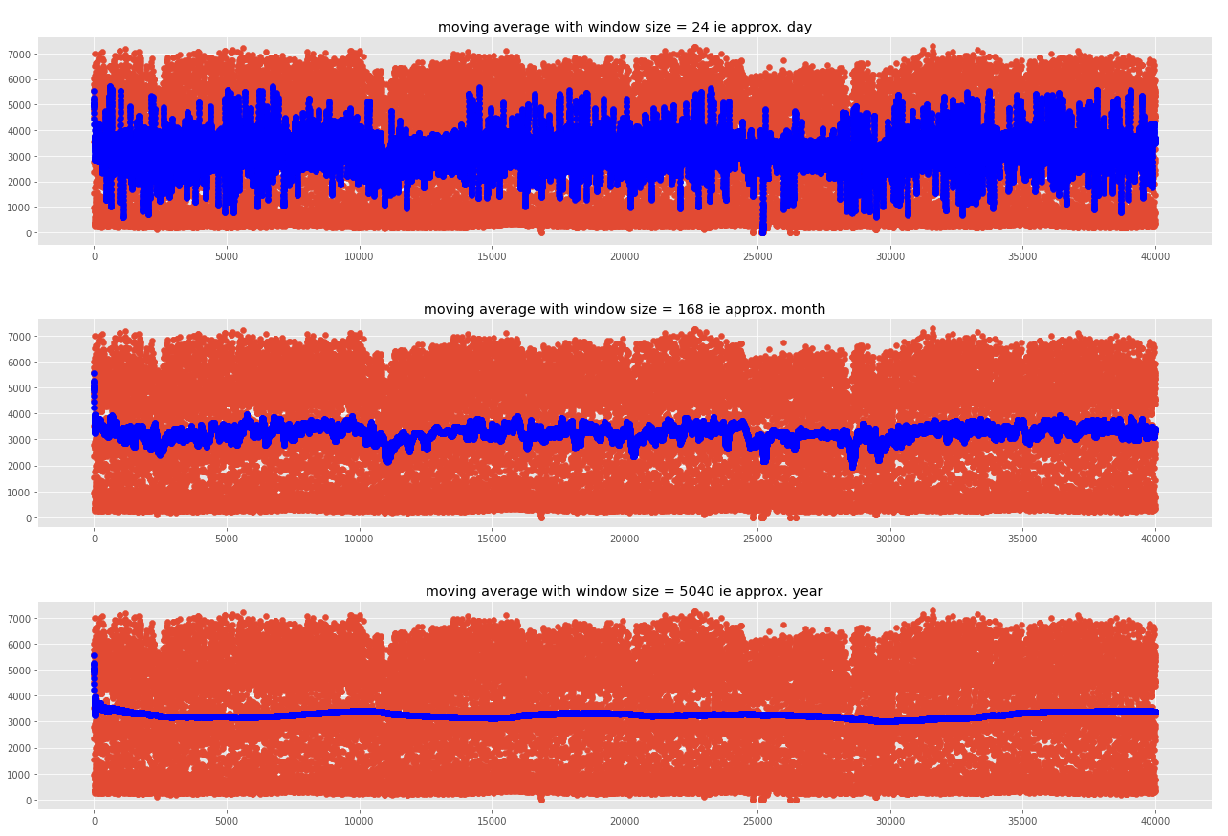
By plotting the autocorrelation plot, we do notice a sinusoidal autocorrelation function, which is a synonym for seasonality. As for the trend term, plotting the moving average by month and by year shows a relatively constant mean and thus can assume in first instance that the trend is constant

To account for the seasonal trend only, we can apply the Holt-Winters methods with a seasonal trend corrected smoothing and neglecting the linear trend term.

2.2.3 Holt-Winters exponential smoothing
- Since the hour variable is the most influential one, we can first develop a model with an hourly seasonal variation (L=24).
- Y_{t} = β₀ + β₁t + SN_{t} + ε_{t} with β₁t=0 meaning that Y_{t} = β₀ + SN_{t} + ε_{t}
with the following update:
L_{n} =α(Y_{n} − SN_{n−L} ) + (1 − α)(L_{n−1} )
SN_{n} =δ(Y_{n} − L_{n} ) + (1 − δ)SN_{n−L}
- Applying this methods would require a uniformly sampled data with exactly one row per hour ie no duplicated or missing values for a unique hour/date.

2.3 Free form forecasting
We will first apply a linear regression using features non related to time and dummy variables to model the seasonal variation and then apply an ARIMA modal (or Box-Jenkins methodologies) to modal the residuals of the previous forecast of traffic volumes.
Y_{t} = TR_{t} + SN_{t} + ε_{t}
with TR_{t}+SN_{t} ∼ Linear Regression and ε_{t} ∼ ARIMA(p, q)

2.3.1 Data cleaning
Following data cleaning have been necessary to yields satisfactory results:
-missing data
-wrongly labeled data
-wrong data (outliers in figures)
-resampling

2.3.2 Linear regression
Among the different linear regression tested, the model with interaction included obtained by forward selection one has yielded the best performance when comparing train and test errors relatively to the model complexity.
 | Train errors (MAE) | Test error (MAE)
1-full model | 586.59 | 589.46
2-model obtained by forward selection | 586.91 | 590.15
3-full model with interaction effect | 235.54 | 245.33
4-model with interaction included obtained by forward selection | 254.34 | 261.16

2.3.3 ARIMA
The residuals obtained have been used as entry for an ARIMA modeling. This methodology assumes stationary data i.e. mean, variance and autocorrelation are constant over time.
The ACP reveals however some seasonality effects and also that some portions are not stationary as shown by the varying average on the bottom dark blue plot (bottom left). Differencing the residuals makes the average more stationary (bottom right). However, the lag 1 autocorrelation is too negative and we might have over-differenced.
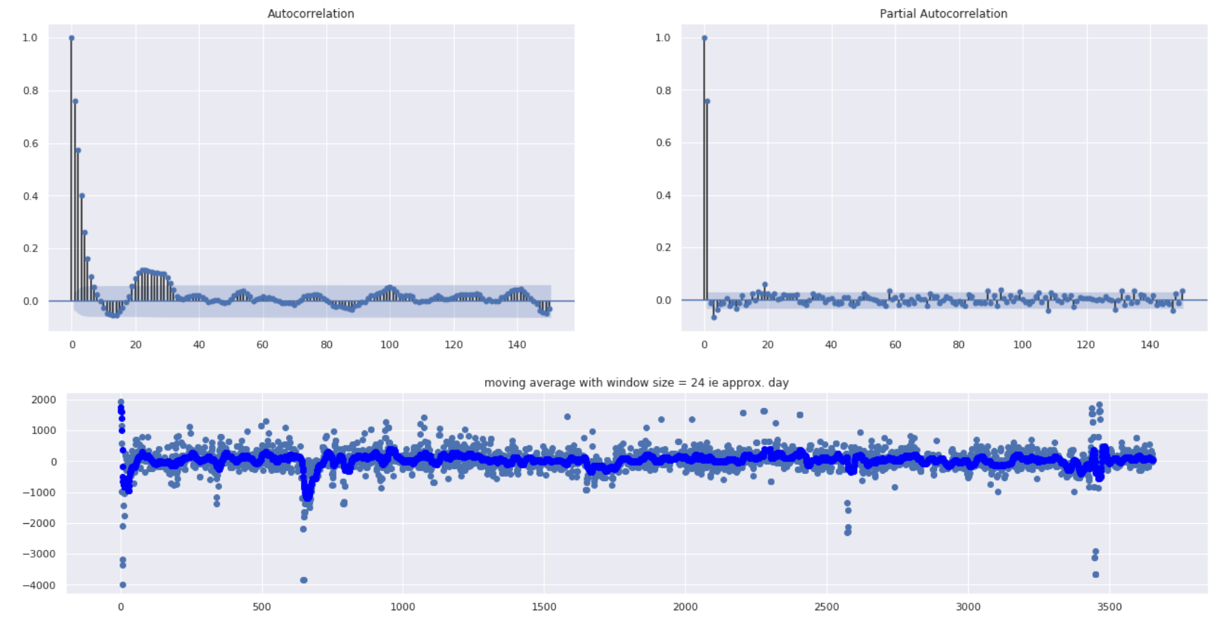
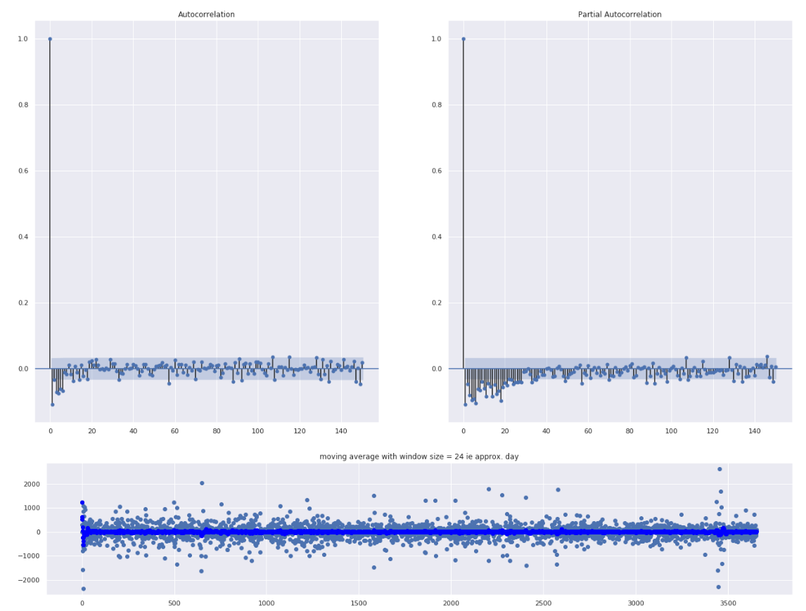
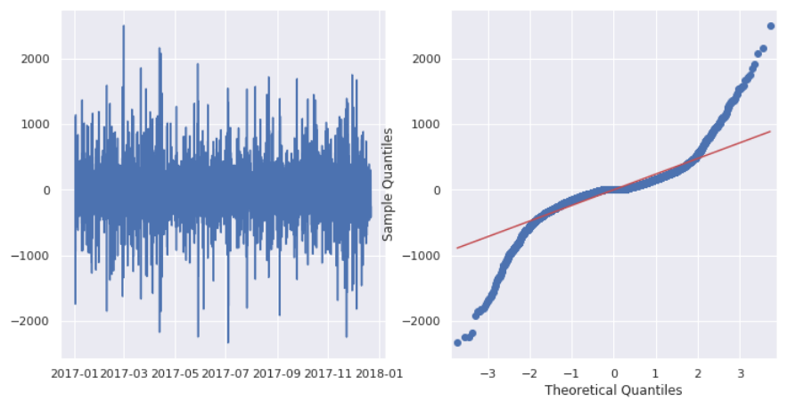

Residuals qq plots

For the AR term, we will look at the Partial autocorrelation plot : lag 1 is quite significant and lag 2 much less. We will tentatively fix the order at p =1.
For the MA term, we will look at the autocorrelation plot. We can tentatively fix it at q=5.
By a gridsearch trough the parameters :

Thus, we need to remove the seasonal term to have a stationary series. Then we will opt for a seasonal ARIMA modal: y _{t} ∼ SARIMA(p, d, q) × (L, P, D, Q)

• L: the period of the seasonal effect
• P : the order of AR part at seasonal level
• Q: the order of MA part at seasonal level
• D: the order of differencing at seasonal level

-At non seasonal level :
First regular differencing : z _{t} = y _{t} − y _{t−1}
-At seasonal level :
First seasonal differencing: z _{t} = y _{t} − y _{t−L} with L = 24 (we need to be cautious though, the data is not completely clean as we do not have data for all hours and some hours have more than data)
-Combined :
First regular and seasonal differencing: z _{t} = y _{t} − y _{t-1} − ( y _{t-L} − y _{t-L-1} )

Autocorrelation plot : 3 spikes for the PACF, we can try a AR(3) modal
autoregressive forecasting models are essentially linear regression models that utilize the lag(s) of the series itself as predictors.
We know that linear regression works best if the predictors (X variables) are not correlated against each other. So, stationarizing the series solves this problem since it removes any persistent autocorrelation, thereby making the predictors(lags of the series) in the forecasting models nearly independent.

Improvements
-Further data quality improvements
-Apply cross validations by randomly selecting samples to predict
-LR

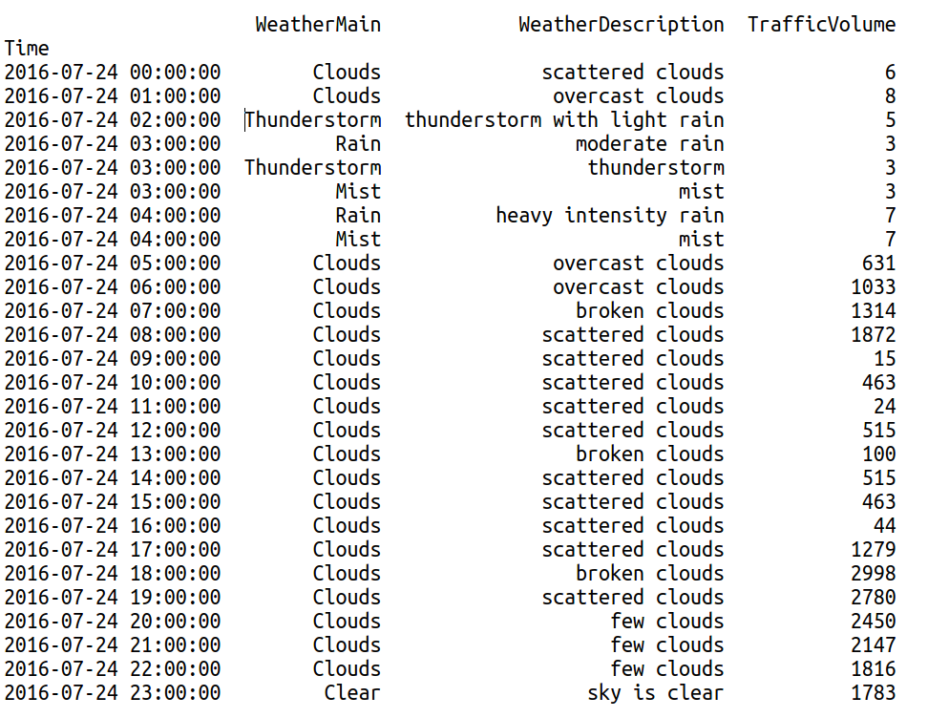
1-deseasonalize a time series needed if that series is stationary ? Is a seasonal series stationary ?
- 1. Take a moving average with length as the seasonal window. This will smoothen in series in the process.

- 2. Seasonal difference the series (subtract the value of previous season from the current value)

- 3. Divide the series by the seasonal index obtained from STL decomposition

